shen_class04.R

celinashen

2024-10-11

#My first Rscript  
x <- 1:50  
plot(x)

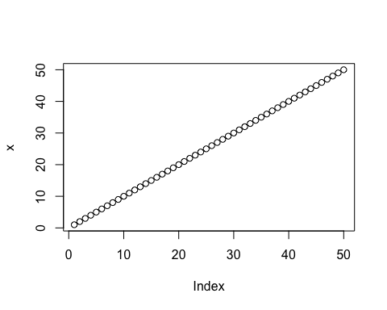

plot(x, sin(x))

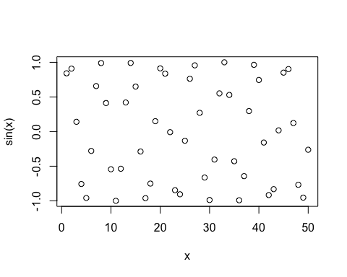

plot(x, sin(x), typ = "l")

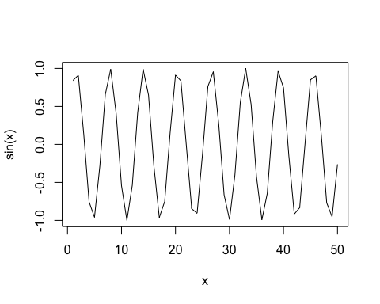

plot(x, sin(x), typ = "l", col = "lightblue")

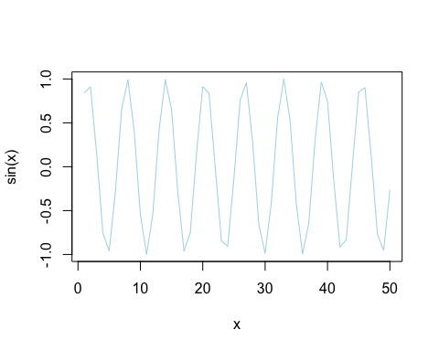

plot(x, sin(x), typ = "l", col = "magenta", lwd = 3)

